Part I: Response Analysis

Model | Prompt | Response
Claude  (current free version) | Yeah, could you help me with this query? Find the total number of course enrollments and the average total credits (tot_cred) of students in each department. Rank departments from highest enrollment count to lowest. | 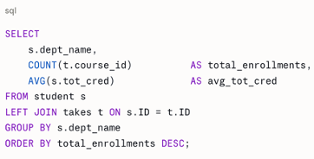
Chat GPT (current free version) | I was hoping you could help me query this: for each instructor, can you list their name, department, the courses they teach, the semester and year, and the number of students enrolled in each of their sections? Include only sections with at least 10 students. | 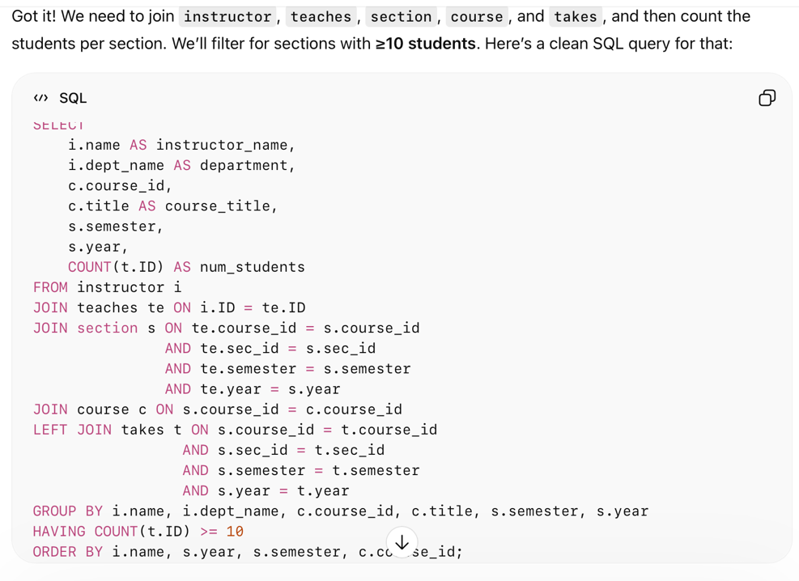
Google Gemini (current free version) | Can you find all courses where every section ever offered had at least one student who received an ‘A’ grade? | 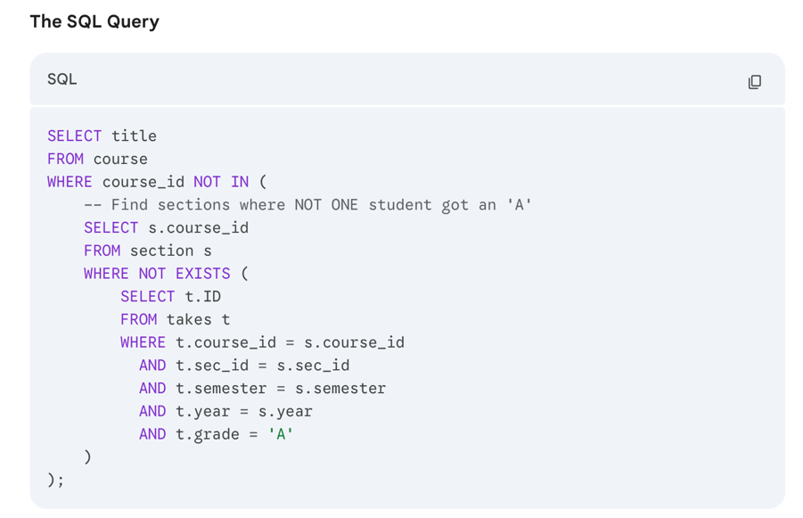
DeepSeek (current free version) | Err I had a specific query in mind. For each department, rank instructors by salary from highest to lowest. Show the instructor’s name, department, salary, their rank within the department, and what percentile they fall into. | WITH instructor_rankings AS (  SELECT  i.name,  i.dept_name,  i.salary,  ROW_NUMBER() OVER (PARTITION BY i.dept_name ORDER BY i.salary DESC) as rank_in_dept,  ROUND(  PERCENT_RANK() OVER (PARTITION BY i.dept_name ORDER BY i.salary DESC) * 100,  2  ) as percentile  FROM instructor i  )  SELECT  name,  dept_name,  salary,  rank_in_dept,  percentile,  -- Optional: Add percentile bucket labels  CASE  WHEN percentile <= 25 THEN 'Bottom 25%'  WHEN percentile <= 50 THEN 'Lower Middle 25%'  WHEN percentile <= 75 THEN 'Upper Middle 25%'  ELSE 'Top 25%'  END as percentile_bucket  FROM instructor_rankings  ORDER BY dept_name, rank_in_dept;
Meta AI (current free version) | Find students who have taken courses offered by at least 3 different departments but have never taken a course taught by their own advisor. | 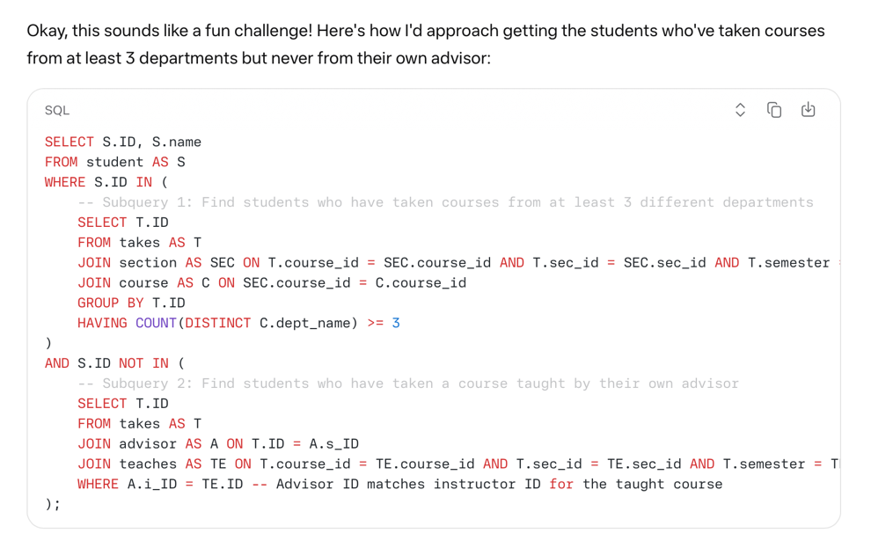

Part II: Response Analysis

Prompt | Model | Notes
Query I – Aggregation | Claude | - Straightforward prompt with a pretty straightforward response.  - Specifies “left join” where I didn’t specifically request it. Not wrong, just makes an assumption about how I want to deal with students with 0 enrollment.  - Shortens variable names to letters, which is convenient.
Query II – Multitable Join | ChatGPT | - Is very verbose and returns more information than strictly asked for (e.g. returns the course ID AND title when only one was needed).  - Robotic about using JOIN/ON/AND; uses “left join,” which specifically includes empty sections and is an odd logical choice.
Query III – Correlated Subquery | Gemini | - Correct logical assumption with WHERE NOT EXISTS  - Selects title from course, which assumes all courses only have one title; this is not necessarily true, especially with merged cross-disciplinary classes.
Query IV - Window | DeepSeek | - Offers significant explanatory justification and unsolicited “add-ons.”  - Continually re-referenced variable names instead of using GROUP BY  - “What percentile they fall into” is grammatically vague. Instead of asking for clarification, they assumed I meant individual professors within the department and by salary, not by another element in the dataframe or departments ranked against one another.
Query V - Complex | Meta | - “Top down” sort of logic: read the request and basically approach it as two separate requests, even though they’re conceptually related.  - Refers to T.ID before defining T.  - Tried to comment out with incorrect syntax.

Part III: EXPLAIN ANALYZE

Prompt, Model | EXPLAIN ANALYZE | Issues
QI / Claude | 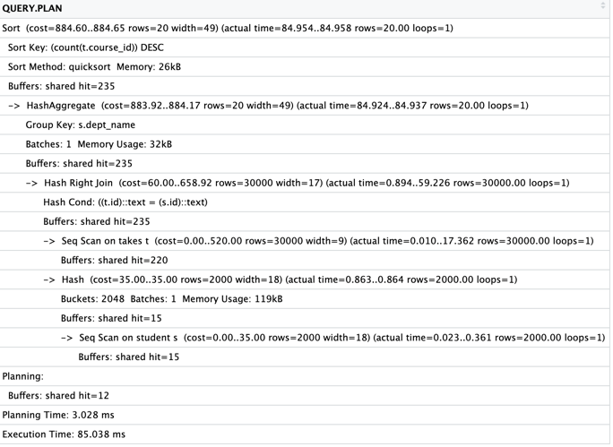 | - Keeps using seq-scan despite only requiring the index for future selections. This means it reads thousands of rows each time, even though the data has already been sorted.  - Since it starts by filtering for course description, the shared buffer hits is good relative to the table size.
Q2 / ChatGPT | 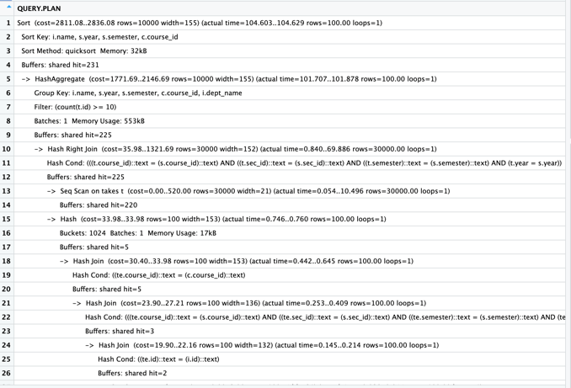  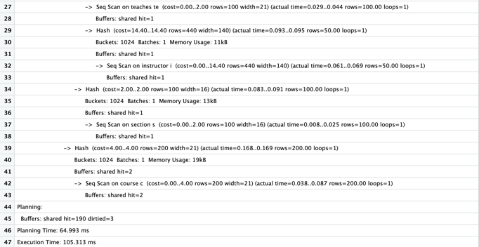
Q3 / Gemini | 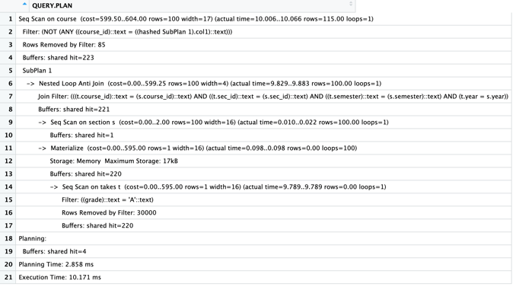 | - Something is wrong with the Seq Scan on takes t, which removes 30000 rows.  - Filters for grade == “A” as text, possibly filtering out A+ / A- or grade stored in other format. Though this is irrelevant due to the aforementioned filtering issue.
Q4 / DeepSeek | 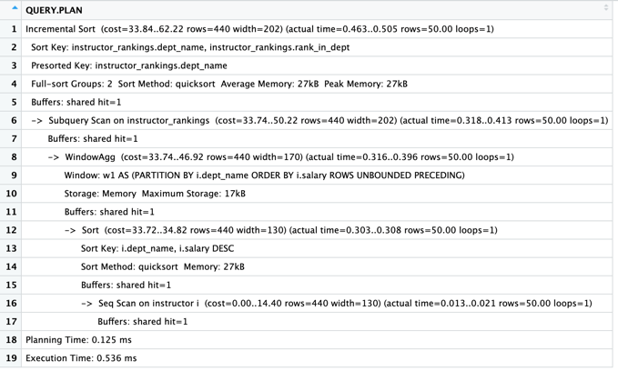 | - For the subquery scan, expected 440 rows but only got 50.
Q5 / Meta | 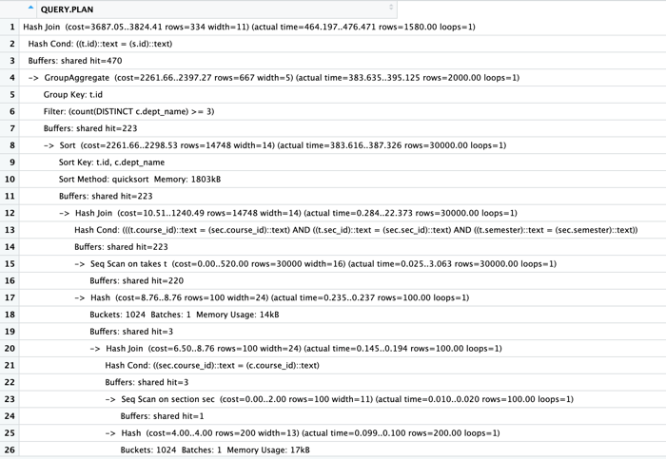  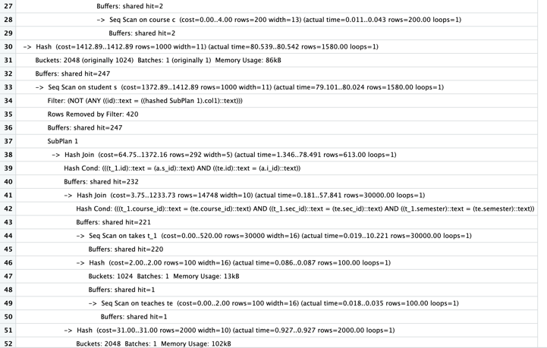  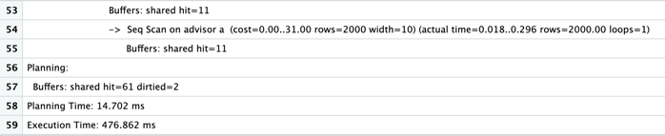 | - Consistently underestimates actual number of rows.

Part IV: Optimized Queries

Prompt, Model | Improved Query | Performance Note

Part V: Personal Reflection

Appendix: AI Conversation Logs
Query I: Claude
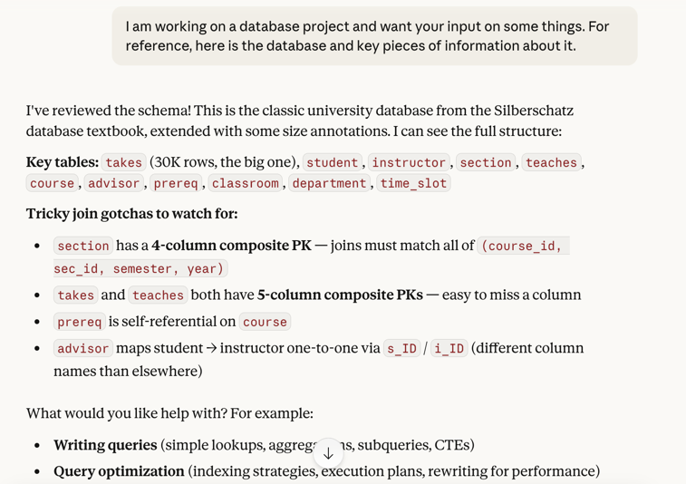
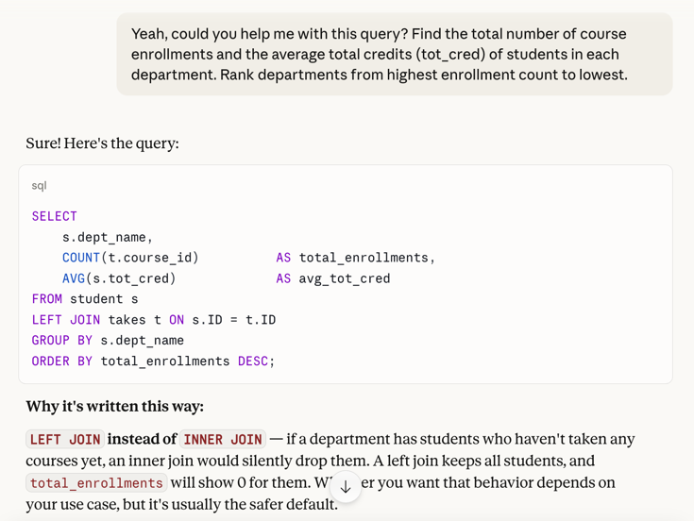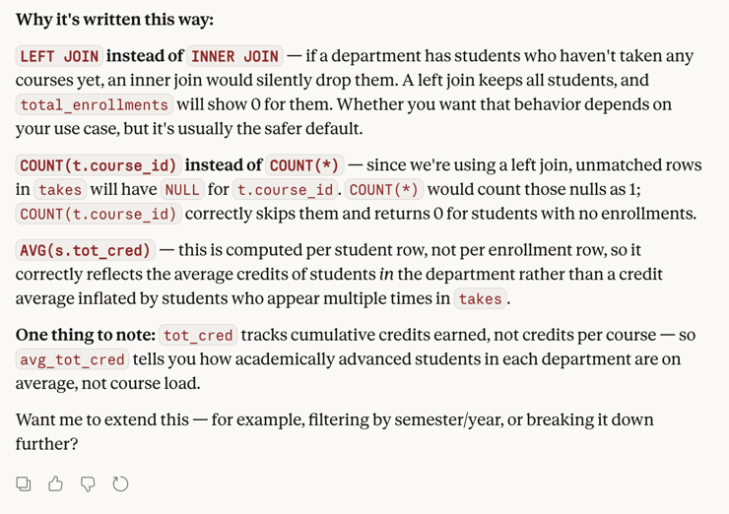
Query II: ChatGPT


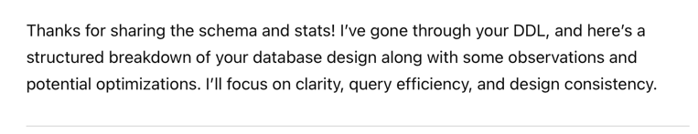

[Returned a lot of summary information that was generally irrelevant]
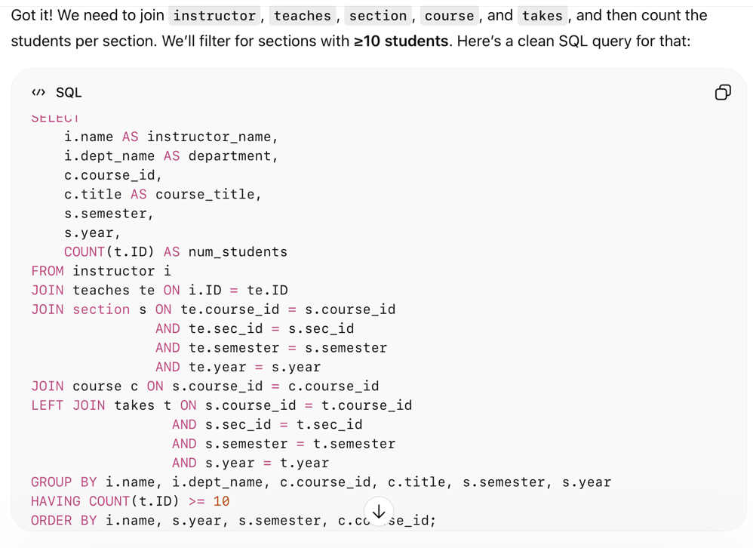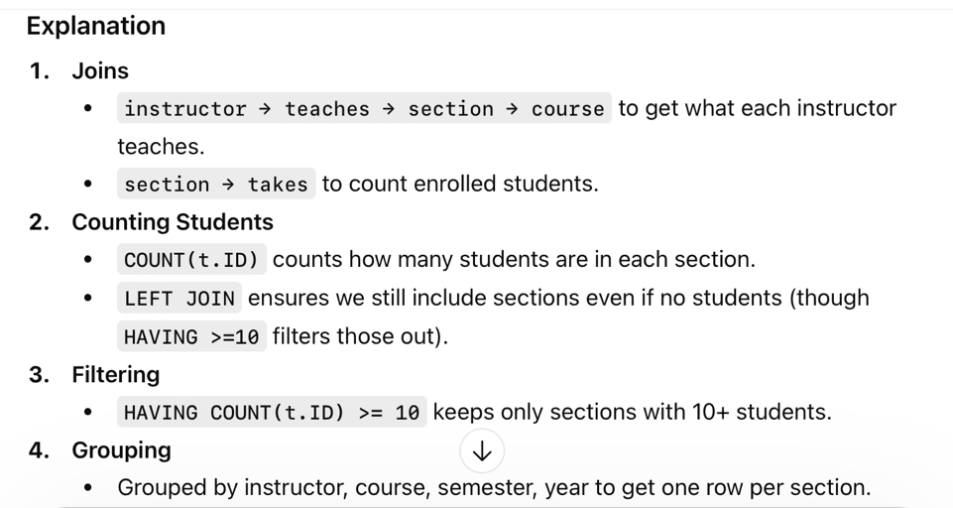

Query III: Google Gemini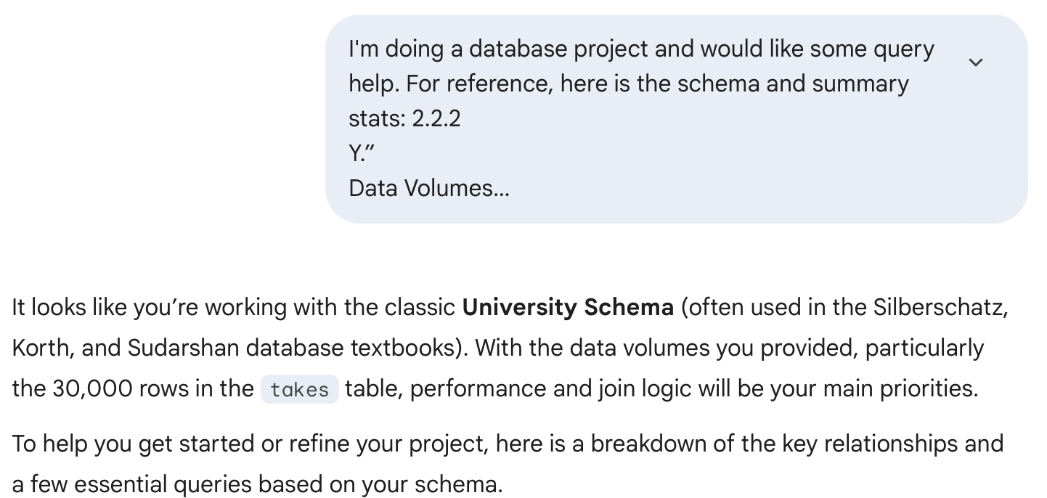
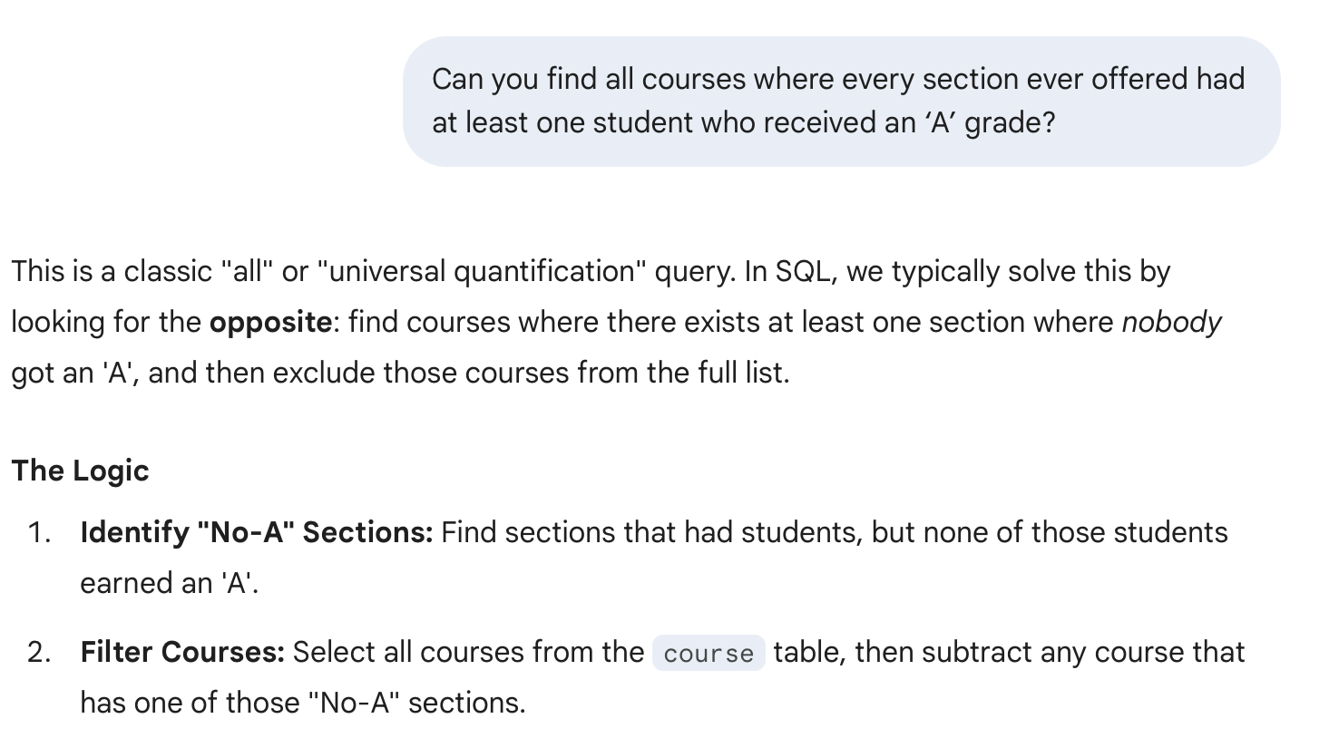
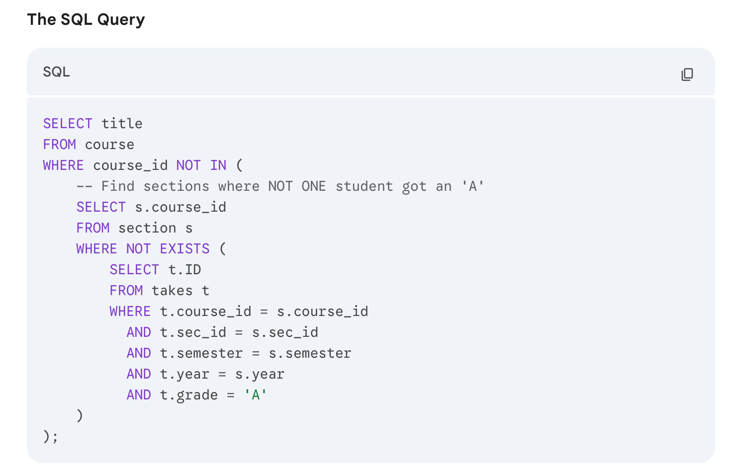

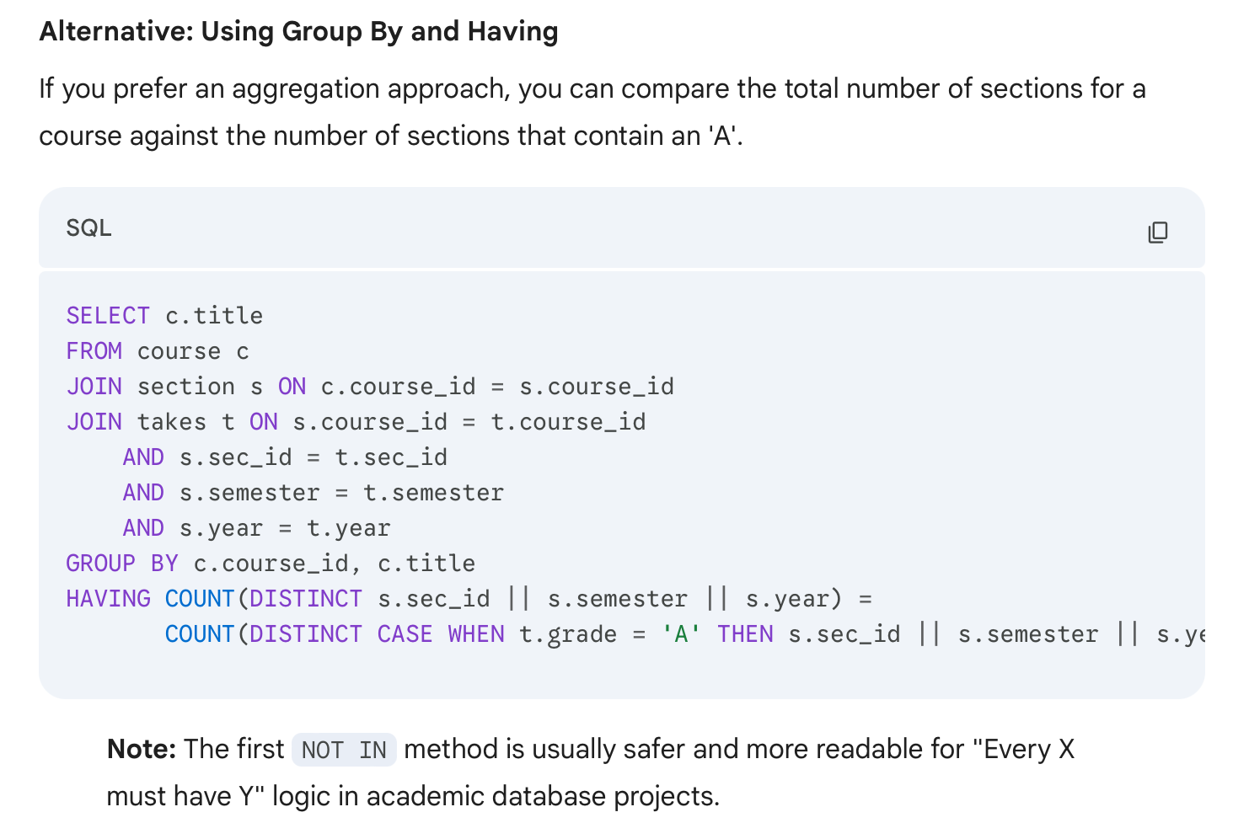

Query IV: DeepSeek
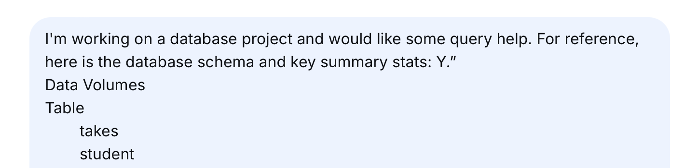
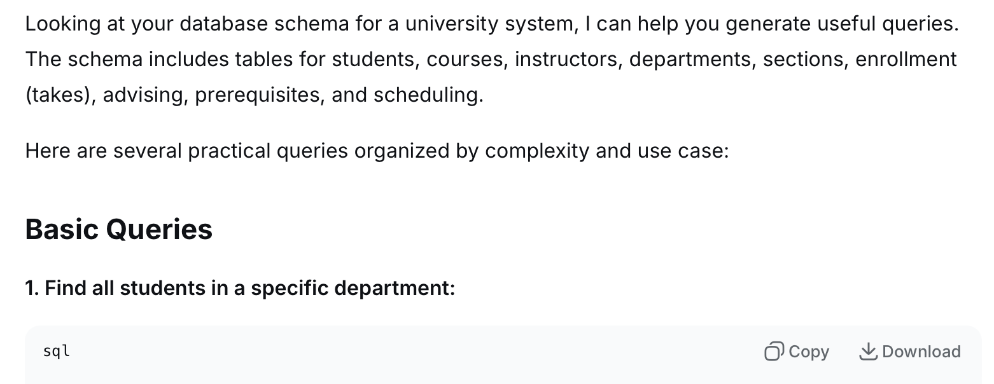
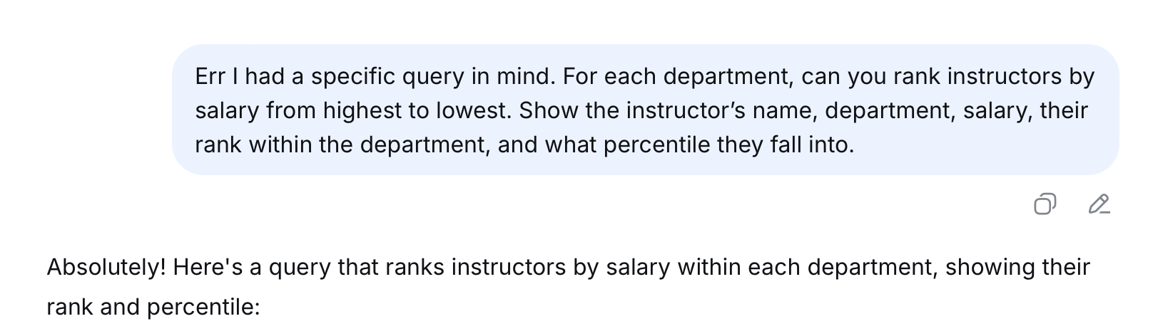
WITH instructor_rankings AS (
SELECT
i.name,
i.dept_name,
i.salary,
ROW_NUMBER() OVER (PARTITION BY i.dept_name ORDER BY i.salary DESC) as rank_in_dept,
ROUND(
PERCENT_RANK() OVER (PARTITION BY i.dept_name ORDER BY i.salary DESC) * 100,
2
) as percentile
FROM instructor i
)
SELECT
name,
dept_name,
salary,
rank_in_dept,
percentile,
-- Optional: Add percentile bucket labels
CASE
WHEN percentile <= 25 THEN 'Bottom 25%'
WHEN percentile <= 50 THEN 'Lower Middle 25%'
WHEN percentile <= 75 THEN 'Upper Middle 25%'
ELSE 'Top 25%'
END as percentile_bucket
FROM instructor_rankings
ORDER BY dept_name, rank_in_dept;

Alternative using DENSE_RANK (if you want ties to share rank)

WITH instructor_rankings AS (
SELECT
i.name,
i.dept_name,
i.salary,
DENSE_RANK() OVER (PARTITION BY i.dept_name ORDER BY i.salary DESC) as rank_in_dept,
ROUND(
PERCENT_RANK() OVER (PARTITION BY i.dept_name ORDER BY i.salary DESC) * 100,
2
) as percentile,
-- Also show what percentage of department salary they represent
ROUND(
100.0 * i.salary / SUM(i.salary) OVER (PARTITION BY i.dept_name),
2
) as pct_of_dept_budget
FROM instructor i
)
SELECT
name,
dept_name,
salary,
rank_in_dept,
percentile || '%' as percentile_rank,
pct_of_dept_budget || '%' as pct_of_dept_payroll
FROM instructor_rankings
ORDER BY dept_name, rank_in_dept;

If you want to show the top 3 per department only:

WITH instructor_rankings AS (
SELECT
i.name,
i.dept_name,
i.salary,
ROW_NUMBER() OVER (PARTITION BY i.dept_name ORDER BY i.salary DESC) as rank_in_dept,
NTILE(4) OVER (PARTITION BY i.dept_name ORDER BY i.salary DESC) as quartile,
ROUND(
PERCENT_RANK() OVER (PARTITION BY i.dept_name ORDER BY i.salary DESC) * 100,
2
) as percentile
FROM instructor i
)
SELECT
name,
dept_name,
salary,
rank_in_dept,
percentile || '%' as percentile_rank,
CASE quartile
WHEN 1 THEN 'Top 25%'
WHEN 2 THEN 'Second 25%'
WHEN 3 THEN 'Third 25%'
WHEN 4 THEN 'Bottom 25%'
END as quartile_label
FROM instructor_rankings
WHERE rank_in_dept <= 3 -- Only top 3 per department
ORDER BY dept_name, rank_in_dept;
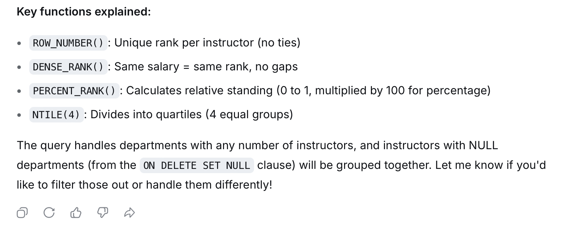
Query V: Meta AI



